Team Activity - Week 5
Objective: Practice SQL queries on the course database(s).

Question 1
Team Leader: Saúl Abraham Arana Calderón
Question: Count how many works of art each artist has (show artist's name and quantity).

SQL
USE v_art;
SELECT artist.fname First_Name, artist.lname Last_Name, COUNT(artwork.artwork_id) AS Total_Pictures
FROM artist
JOIN artwork ON artist.artist_id = artwork.artist_id
GROUP BY artist.artist_id;
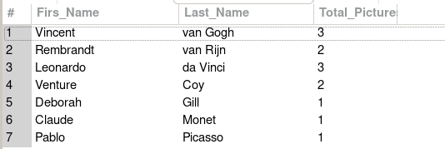

Question 2
Team Leader: Saúl Abraham Arana Calderón
Question: List all works containing the keyword “landscape”.

SQL
USE v_art;
SELECT artwork.title, keyword.keyword
FROM artwork
JOIN artwork_keyword ON artwork.artwork_id = artwork_keyword.artwork_id
JOIN keyword ON artwork_keyword.keyword_id = keyword.keyword_id
WHERE keyword.keyword = 'landscape';
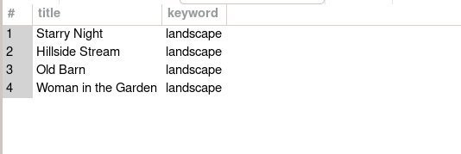

Question 3
Team Leader: Saúl Abraham Arana Calderón
Question: Find the year of the oldest work for each artist's country.

SQL
USE v_art;
SELECT artist.fname First_Name,artist.lname Last_Name, artist.country, MIN(artwork.artyear) AS Oldest_Picture
FROM artist
JOIN artwork ON artist.artist_id = artwork.artist_id
GROUP BY artist.country;
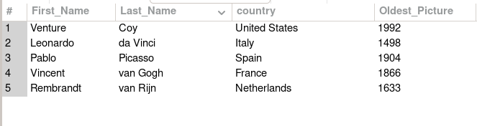

Question 4
Team Leader: Saúl Abraham Arana Calderón
Question: Count how many orders each employee (staff) handled in 2017.

SQL
USE bike;
SELECT co.staff_id ID, st.first_name First_Name, st.last_name Last_name, COUNT(co.cust_order_id) AS total_orders
FROM cust_order co
LEFT JOIN staff st
ON st.staff_id = co.staff_id
WHERE YEAR(order_date) = 2017
GROUP BY co.staff_id;
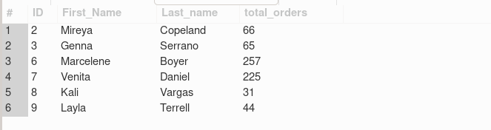

Question 5
Team Leader: Saúl Abraham Arana Calderón
Question: Show orders with status “4” (completed) that required more than 5 days to ship.

SQL
USE bike;
SELECT cust_order_id, order_date, shipped_date
FROM cust_order
WHERE order_status = 4
AND DATEDIFF(shipped_date, order_date) > 5;
